Report on Romanian Organizations Based in the US
Alex Trufinescu
Summary
This study sought to analyze the Romanian American community through its registered charities and organizations. Information concerning their location, finances, religious affiliation, web presence, and more, was gathered through a number of resources. This was all compiled in a comprehensive directory of Romanian American organizations. There were numerous findings in this study. Geographically, Romanian American organizations were found in most major regions of the United States, with a noticeable absence only in the Midwest and the non-continental areas of the country. In terms of religious affiliation, 155 of the 228 organizations found had some sort of religious affiliation while 73 organizations had no religious affiliation. This study chose to focus primarily on the non-religious group of organizations. Financially, only 14 of the 73 non-religious organizations were determined by the study to be financially strong. In terms of age, sources used for the study did not offer much information regarding the date of founding for these organizations, but it was determined that the non-religious organizations were overall more recently founded than the religious organizations. This research was conducted by me, Alex Trufinescu. At the time of writing this report, I am a rising sophomore at Wesleyan University.
Methods
Information that was collected for this study was the official name of the organization, type of organization, religious affiliation (Y/N), principal address, registered agent name, website URL, last tax period, certain financial information (gross receipt, expenses, assets of last tax period), and the names of any board members.
This data was collected primarily from the IRS database for non-profits. All the files available through this resource were filed directly from the organization itself, as opposed to being obtained from a third party. The format was also consistent from organization to organization and from state to state, due to the IRS being a federal agency. For these reasons, this resource proved to have the most reliable and complete information. Additional research was conducted using the state-level secretary of state websites as well as commercial “charity navigators”. However, these were used sparingly. Demographic information about the general Romanian population of each state was gathered from the 2018 American Community Survey, conducted by the US Census Bureau.
In searching for organizations, the keyword “Romania” and “Romanian” were used with all of these resources. This proved to be the most efficient way to gather a list of organizations affiliated with Romania, but it perhaps left out any similarly affiliated organizations that did not include these words in their names. For this reason, the data collected is perhaps an undercount from the true number of Romanian-affiliated organizations.
Results
The Romanian population was found to be distributed throughout the entire United States, through some areas had far larger communities than others. Romanian Americans were found to be concentrated in the West, the Mid-Atlantic, and the Great Lakes regions, with significant communities found in New England and the South as well. This can be observed in the map below.

In total, 228 organizations were found and researched in the study. Their geographic distribution can be seen in the map below.

The study found that, generally, a higher Romanian population in a state meant a higher number of Romanian organizations in that state as well. This trend can be observed by comparing the top 10 states in terms of their Romanian population and their number of Romanian organizations.
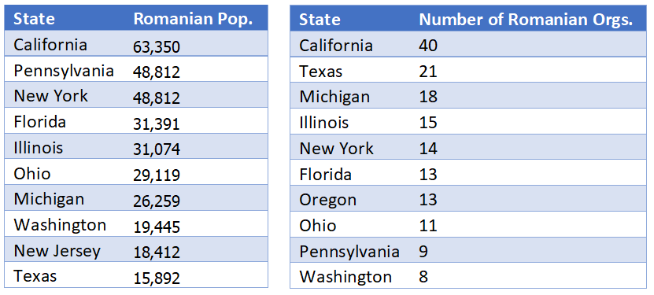
As can be seen, the nine of the ten states with the highest Romanian populations are also nine of ten states with the highest number of registered Romanian organizations.
Out of the 228 organizations, 73, or about 32%, did not have a religious affiliation, while 155, or about 68%, had some sort of religious affiliation. The geographic distribution of non-religious and religious organizations can be seen in the maps below.

The greater amount of religious to non-religious organizations is a trend that holds true in almost every state.
Non-religious organizations were divided according to financial strength. In order to be considered “financially strong”, the organization was required to have a gross receipt higher than $50,000. In the IRS database, only organizations that satisfied this requirement had further files detailing other financial information, such as expenses and assets. Out of the 73 non-religious organizations, 12 were classified as financially strong based on this requirement, seen below along with other related financial information.
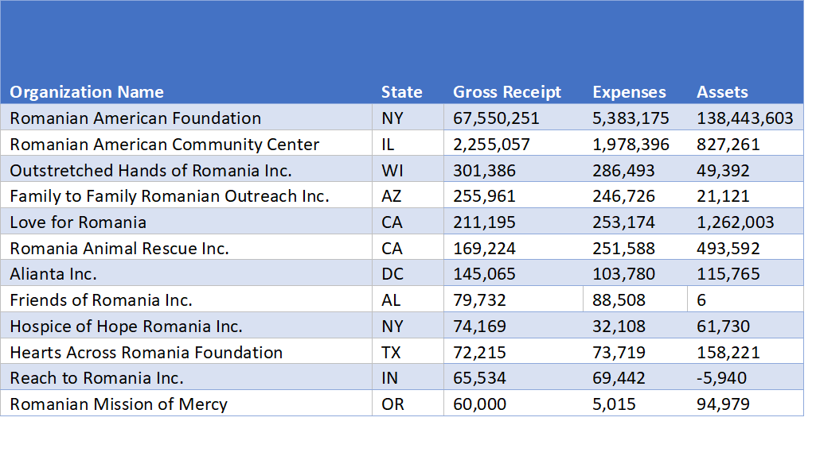
Though classified as financially strong, some organizations can be seen as having negative assets and/or far higher expenses than assets, among them being the Romanian Community Center, Outstretched Hands of Romania Inc., Family to Family Romanian Outreach Inc., Friends of Romania Inc., and Reach to Romania Inc. These numbers are only reports from the last tax period, however, and may not be representative of the overall past and future success of the organizations.
Among financially strong organizations, the gross receipts for which their status is based off of vary widely. This can be seen in the graph below.

The Romanian American Foundation (RAF), registered in New York City, New York, noticeably dwarfs the other organizations in its gross receipt amount. This is likely due to the organization being a direct successor of the Romanian-American Enterprise Fund (RAEF), founded by Congress in 1994 and being directly funded by the US Agency for International Development.
In a second chart that removes the RAF, a better comparison can be made among the gross receipts of the remaining 11 organizations.

The Romanian American Community Center, located in Chicago, Illinois, has a significantly larger gross receipt than the other ranking organizations. From the Outstretched Hands of Romania Inc., headquartered in New Berlin, Wisconsin, there is a more gradual decrease in gross receipt amount.
The age of the organizations was difficult to determine, as most tax forms did not indicate a founding date. Based on some surface research, however, religious organizations seemed more likely to be older than non-religious organizations. According to the online resources of many of the religious organizations, most of which are churches, many share a common history of being founded by Romanian immigrants in the late 1800s and early 1900s. The strong faith of many of these immigrants led to religion becoming the center of their efforts in community-building in their new adopted homeland. This is especially true of organizations located in the Northeast and the Great Lakes regions. In contrast, many of the non-religious organizations were largely founded either by more recent immigrant communities or by non-Romanians, likely in response to the opening of Romania to foreign aid following the fall of the Communist government.
Though all the organizations have a common association with Romania, they were found to focus on a wide variety of missions and issues. The illustrations below display words that appear in each of the organizations’ titles, divided between, firstly non-religious, then religious organizations.
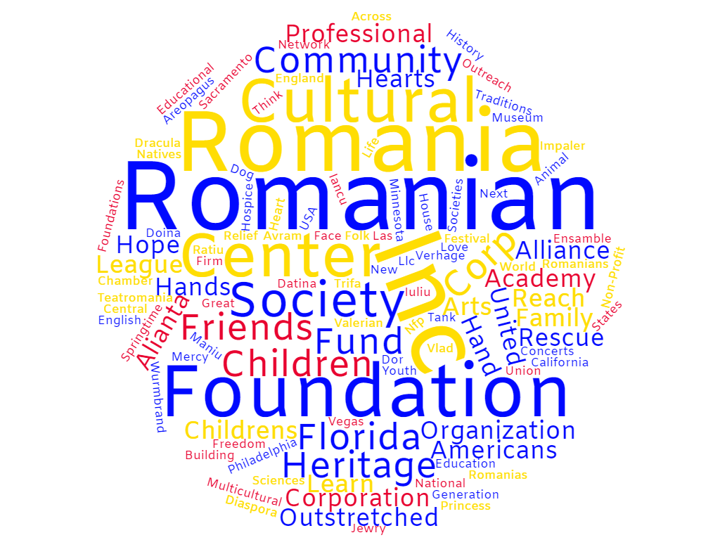
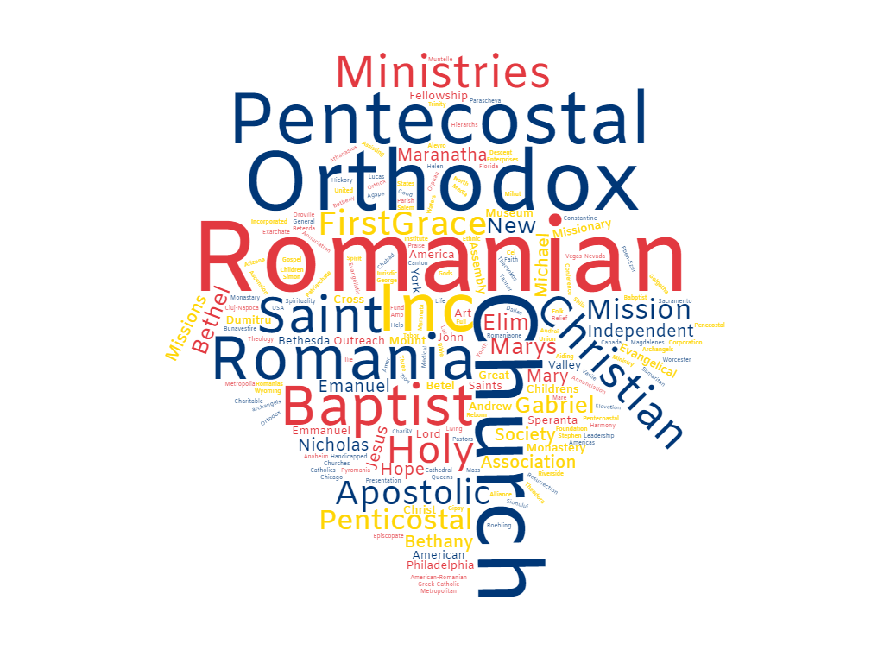
Conclusion
Romanian organizations in the United States display a great deal of diversity in their geographic locations, religious affiliation, finances, purpose, and many more key factors. Perhaps one of the most important takeaways of the study was the relatively small number of large scale, financially strong, non-religious organizations. There are far more Romanian organizations operating at a smaller scale, and perhaps more that may not have been registered with the resources that were used in this study. This is worth further exploration in the future.

